Constructing Ray

Definition
# Source: AI Source: Provided by: [Data Path: Persons Table -> ID Column: 1, Name_En Column: Motasem Essam] -> From: [ChatGPT] on [7/25/2026]
Constructing a Ray is the geometric construction of a ray that begins at a given endpoint and extends infinitely in one direction.
A ray with endpoint $A$passing through point $B$is written as:
$$\boxed{\vec{AB}}$$
Here:
- $A$is the endpoint.
- $B$is a point that determines the direction of the ray.
- The ray continues indefinitely beyond $B$.
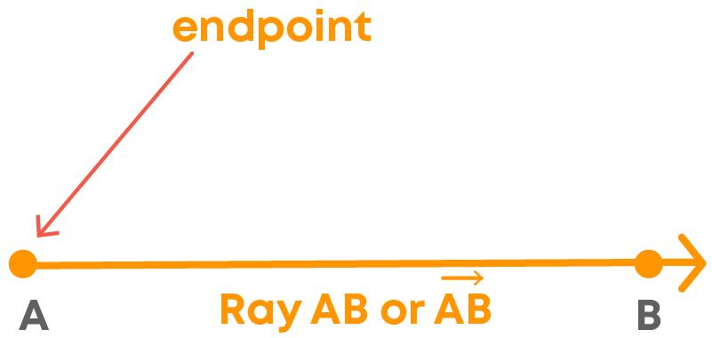
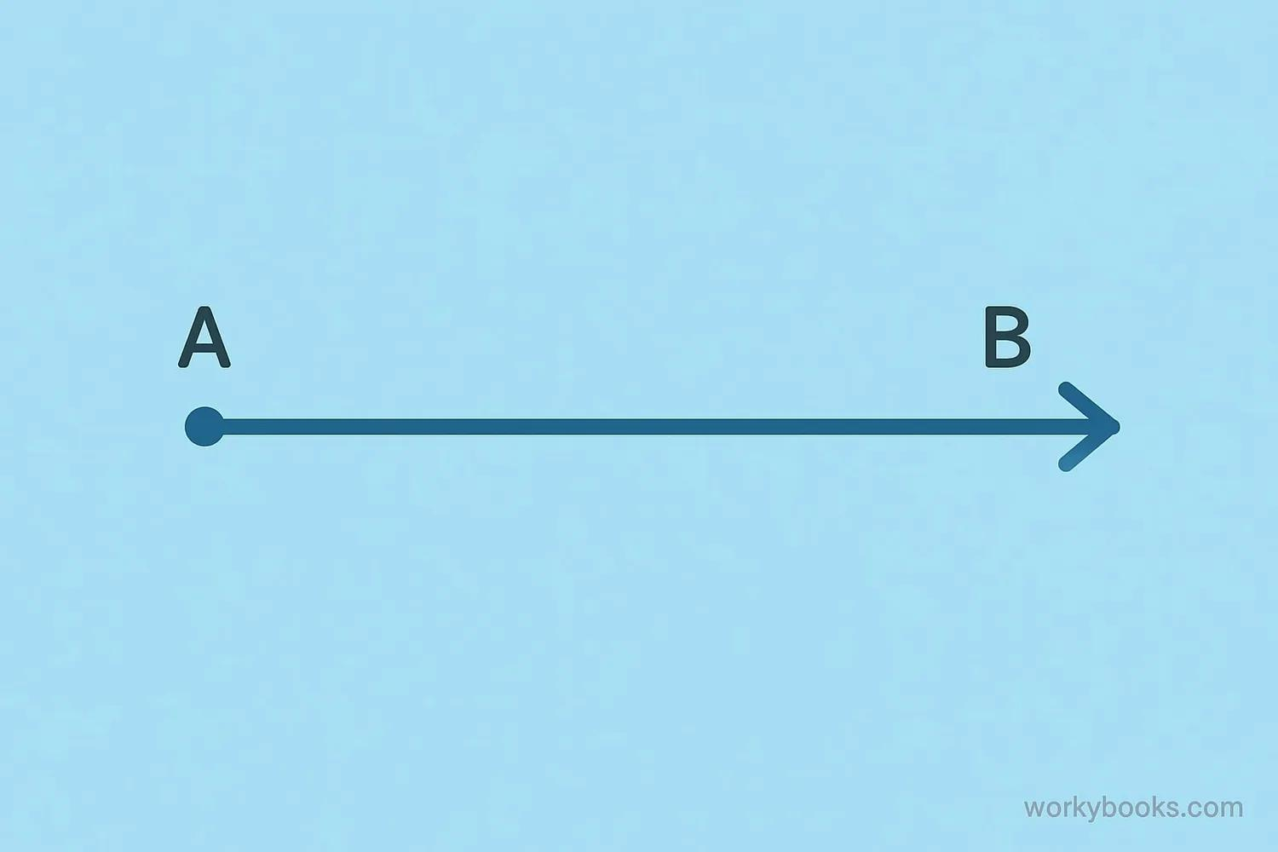
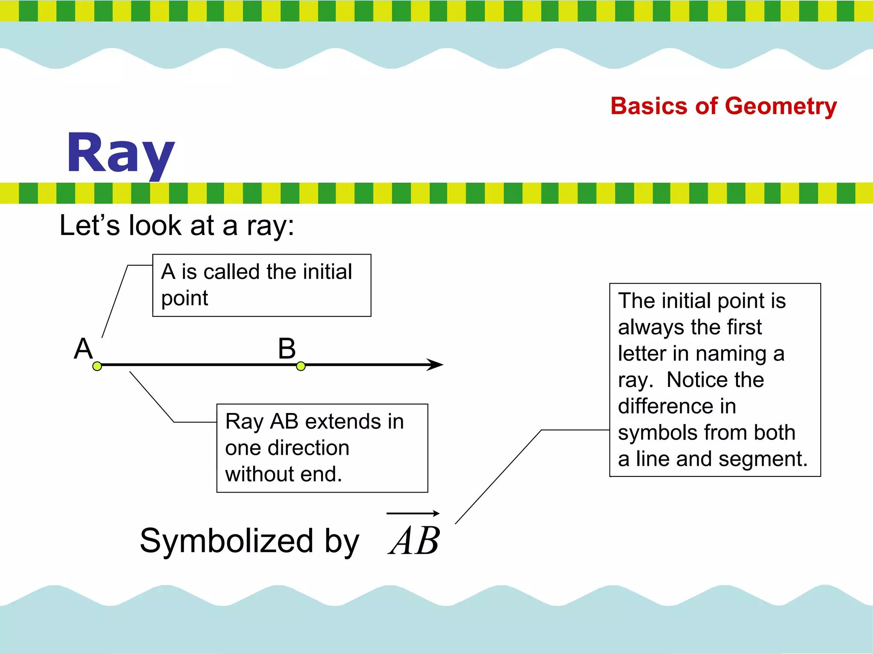

Fundamental Concept
# Source: AI Source: Provided by: [Data Path: Persons Table -> ID Column: 1, Name_En Column: Motasem Essam] -> From: [ChatGPT] on [7/25/2026]
A ray is determined by:
- A fixed endpoint.
- A direction from that endpoint.
If $A$is the endpoint and $B$determines the direction, then:
$$\boxed{\vec{AB}}$$
represents the part of line $AB$beginning at $A$and extending infinitely through $B$.

Basic Construction

Constructing a Ray Through Two Given Points
# Source: AI Source: Provided by: [Data Path: Persons Table -> ID Column: 1, Name_En Column: Motasem Essam] -> From: [ChatGPT] on [7/25/2026]
Suppose $A$and $B$are given points.
Steps
- Identify $A$as the required endpoint.
- Place the straightedge so that it passes through $A$and $B$.
- Draw the line starting at $A$and passing through $B$.
- Extend the drawing beyond $B$in the same direction.
- Mark an arrow on the far end to indicate that the ray continues indefinitely.
The result is:
$$\boxed{\vec{AB}}$$
Representation
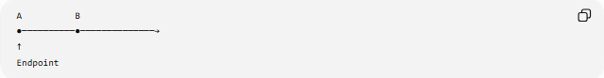
A B
●──────────●──────────────→
↑
Endpoint
The arrow indicates that the ray continues infinitely in one direction.

Constructing a Ray From a Given Endpoint and Direction
# Source: AI Source: Provided by: [Data Path: Persons Table -> ID Column: 1, Name_En Column: Motasem Essam] -> From: [ChatGPT] on [7/25/2026]
Sometimes only an endpoint $A$and a direction are specified.
Steps
- Mark the required endpoint $A$.
- Choose or construct a second point $B$in the required direction.
- Use a straightedge to draw through $A$and $B$.
- Extend the line from $A$through $B$.
- The resulting object is the ray:
$$\vec{AB}$$

Constructing a Ray as Part of an Angle
# Source: AI Source: Provided by: [Data Path: Persons Table -> ID Column: 1, Name_En Column: Motasem Essam] -> From: [ChatGPT] on [7/25/2026]
A ray is also a fundamental component of an angle.
For example:
$$∠ABC$$
has two rays:
$$\boxed{\vec{BA}}$$
and:
$$\boxed{\vec{BC}}$$
Both rays have the common endpoint $B$, which is the vertex of the angle.
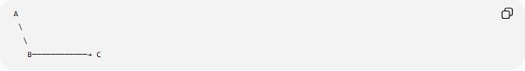
A
\
\
B────────────→ C
Therefore:
$$\boxed{∠ABC=\text{the angle formed by }\vec{BA}\text{ and }\vec{BC}}$$

Constructing a Ray From a Line Segment
# Source: AI Source: Provided by: [Data Path: Persons Table -> ID Column: 1, Name_En Column: Motasem Essam] -> From: [ChatGPT] on [7/25/2026]
A ray can be created by extending a line segment in one direction.
Given:
$$\overset{‾}{AB}$$
Extend it beyond $B$:
$$\boxed{\vec{AB}}$$
A────────B────────────→
The original segment has two endpoints, while the ray has only one endpoint.

Ray vs Line Segment vs Line
# Source: AI Source: Provided by: [Data Path: Persons Table -> ID Column: 1, Name_En Column: Motasem Essam] -> From: [ChatGPT] on [7/25/2026]
Feature | Line Segment | Ray | Line
Notation | $$\overset{‾}{AB}$$ | $$\vec{AB}$$ | $$\overset{↔}{AB}$$
Endpoints | 2 | 1 | 0
Extends infinitely | No | One direction | Both directions
Length | Finite | Infinite | Infinite
Direction | Between two endpoints | One direction | Both directions
Visual Comparison
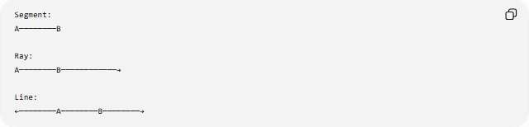
Segment:
A────────B

Ray:
A────────B────────────→

Line:
←────────A────────B────────→

Constructing a Ray Through a Given Point
# Source: AI Source: Provided by: [Data Path: Persons Table -> ID Column: 1, Name_En Column: Motasem Essam] -> From: [ChatGPT] on [7/25/2026]
If a ray must start at $A$and pass through a given point $B$, then the two points uniquely determine its direction.
$$\boxed{A,B⇒\vec{AB}}$$
The straightedge is used to establish the exact direction.

Constructing Opposite Rays
# Source: AI Source: Provided by: [Data Path: Persons Table -> ID Column: 1, Name_En Column: Motasem Essam] -> From: [ChatGPT] on [7/25/2026]
Two rays can have the same endpoint but extend in opposite directions.
For example:
$$\vec{AB}$$
and:
$$\vec{AC}$$
are opposite rays when $A,B,C$are collinear and $A$lies between $B$and $C$.
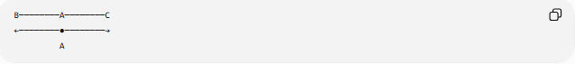
B────────A────────C
←────────●────────→
A
They form a straight angle:
$$\boxed{∠BAC={180}^{∘}}$$

Types of Ray Construction
# Source: AI Source: Provided by: [Data Path: Persons Table -> ID Column: 1, Name_En Column: Motasem Essam] -> From: [ChatGPT] on [7/25/2026]
The construction can be organized into the following descriptive types:
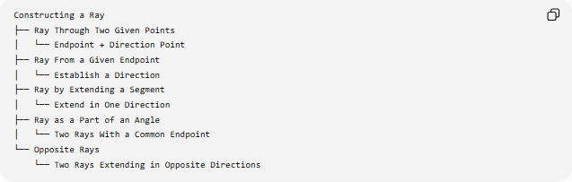
Constructing a Ray
├── Ray Through Two Given Points
│ └── Endpoint + Direction Point
├── Ray From a Given Endpoint
│ └── Establish a Direction
├── Ray by Extending a Segment
│ └── Extend in One Direction
├── Ray as a Part of an Angle
│ └── Two Rays With a Common Endpoint
└── Opposite Rays
└── Two Rays Extending in Opposite Directions
Classification note: These are construction situations rather than universally standardized mathematical “types” of rays. The mathematical object in each case is still a ray.

Tools Used
# Source: AI Source: Provided by: [Data Path: Persons Table -> ID Column: 1, Name_En Column: Motasem Essam] -> From: [ChatGPT] on [7/25/2026]
The basic construction requires a:
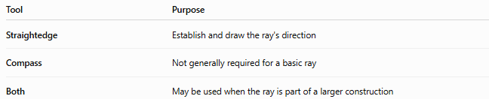
Tool | Purpose
Straightedge | Establish and draw the ray's direction
Compass | Not generally required for a basic ray
Both | May be used when the ray is part of a larger construction
Unlike constructing a specific length, constructing a basic ray does not require measuring its infinite length.

Important Properties
# Source: AI Source: Provided by: [Data Path: Persons Table -> ID Column: 1, Name_En Column: Motasem Essam] -> From: [ChatGPT] on [7/25/2026]
1. One Endpoint
A ray has exactly one endpoint:
$$\boxed{\text{Number of endpoints}=1}$$
2. Infinite Length
A ray continues indefinitely in one direction.
Therefore, its length is not finite.
3. Two Points Determine a Ray
If $A$is the endpoint and $B≠A$determines the direction:
$$\boxed{\vec{AB}}$$
is uniquely determined.
4. Order Matters
In general:
$$\boxed{\vec{AB}≠\vec{BA}}$$
because they have different endpoints and directions.
For example:
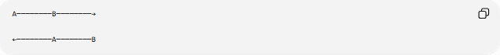
A────────B────────→

←────────A────────B
The first is $\vec{AB}$, while the second is $\vec{BA}$.

Relationship to Other Geometric Constructions
# Source: AI Source: Provided by: [Data Path: Persons Table -> ID Column: 1, Name_En Column: Motasem Essam] -> From: [ChatGPT] on [7/25/2026]
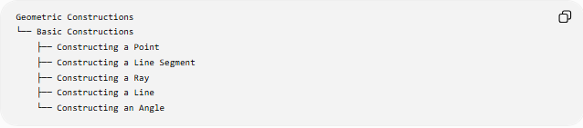
Geometric Constructions
└── Basic Constructions
├── Constructing a Point
├── Constructing a Line Segment
├── Constructing a Ray
├── Constructing a Line
└── Constructing an Angle
A ray is especially important because it is used to construct:
- angles
- triangles
- polygons
- parallel lines
- perpendicular lines
- angle bisectors
- geometric figures

Key Points
# Source: AI Source: Provided by: [Data Path: Persons Table -> ID Column: 1, Name_En Column: Motasem Essam] -> From: [ChatGPT] on [7/25/2026]
- A ray has one endpoint and extends infinitely in one direction.
- It is represented by:
$$\boxed{\vec{AB}}$$
- The first letter identifies the endpoint.
- The second letter identifies the direction.
- A straightedge is sufficient for a basic ray construction.
- A ray can be constructed by extending a segment in one direction.
- Two opposite rays with the same endpoint form a straight angle.
- A ray is different from both a segment and a line.

Conclusion
# Source: AI Source: Provided by: [Data Path: Persons Table -> ID Column: 1, Name_En Column: Motasem Essam] -> From: [ChatGPT] on [7/25/2026]
Constructing a Ray is the process of creating a geometric object with one fixed endpoint and a definite direction extending infinitely. The basic construction is performed by establishing the endpoint and direction, then drawing and extending the ray with a straightedge. Rays are fundamental building blocks of angles, triangles, parallel and perpendicular constructions, and many other geometric figures.

